How to electronically sign documents

A signature is required for many forms requested by financial aid. During the COVID-19 Pandemic, we will be accepting electronic signatures submitted using the following methods.

First Method: Electronic signature in INTERNET EXPLORER (Chrome, Firefox, and Safari are not compatible for electronic signing documents)

Step 1: Find form requested on our website at: https://tncc.edu/admissions/forms
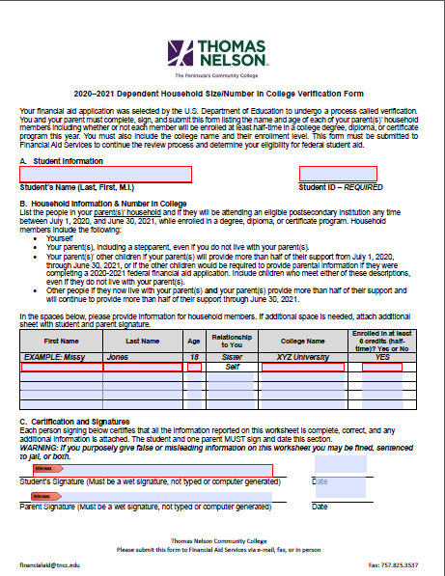

You should see the blue fillable boxes on the form

Step 2: Complete the form

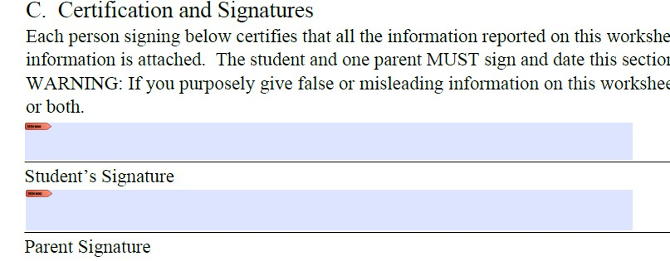

Step 4: Create New digital ID, if you do not have one already and select Next >

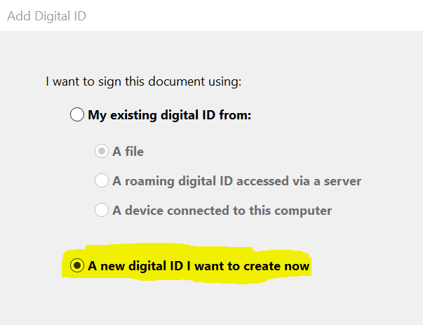

Step 5: Select “New PKCS#12 digital ID file” and Select Next >

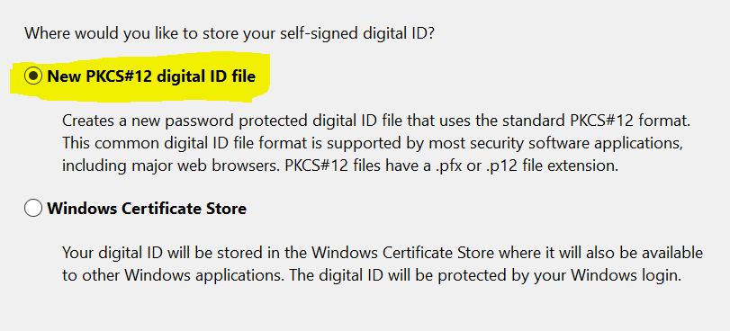

Step 6: Complete fields requested and select Next >

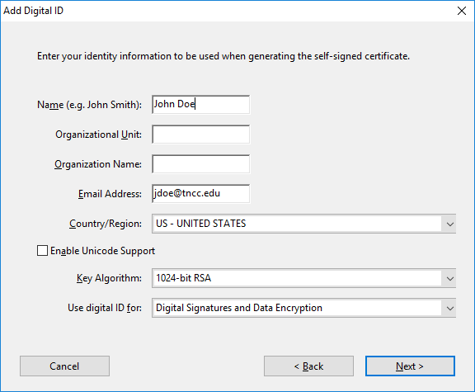

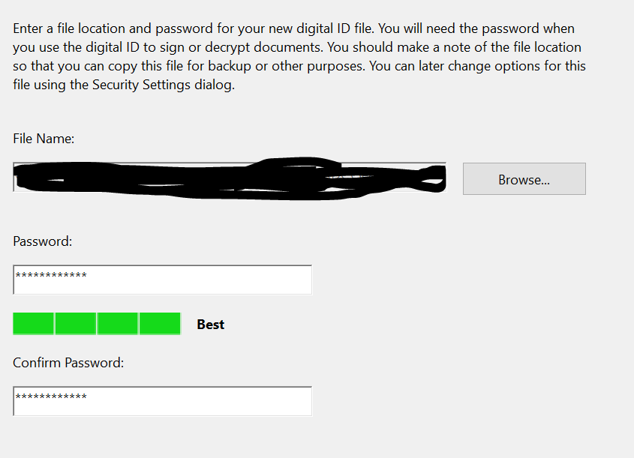

Step 8: You will have an electronic signature stamp

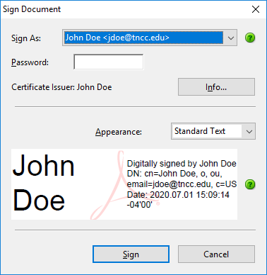

Step 9: Enter the password you previously created and click ‘Sign’

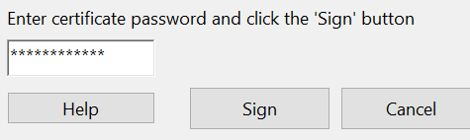

Step 10: Now your form should contain the digital signature as seen below

Step 11: Save document to your computer.
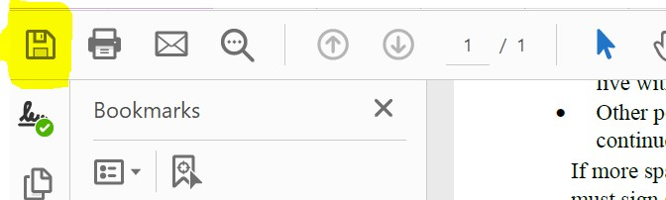

Documents may be submitted through email at financialaid@tncc.edu or our website https://mysupport.tncc.edu/sims/helpcenter/common/layout/SelfHelpHome.seam?inst_name=vccs-thomasnelson

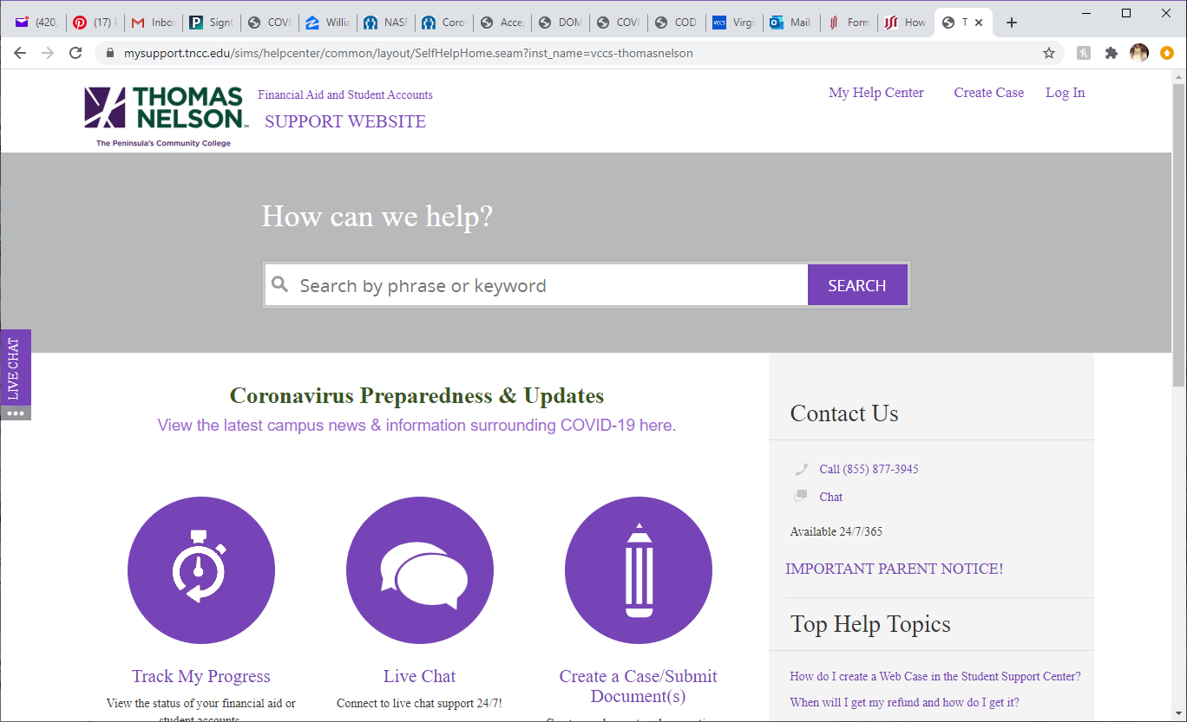

Second Method: Using Adobe Reader DC

If you are using a browser other than Internet Explorer, you can download adobe reader for free and follow the steps below on creating an electronic signature.

Step 1: Open document from our forms page at: https://tncc.edu/admissions/forms
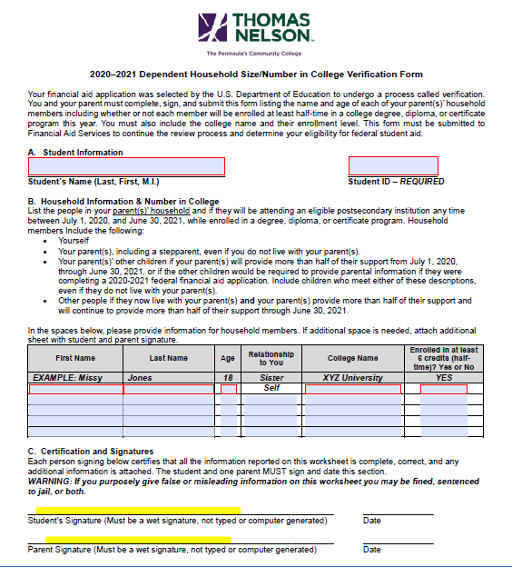
As you can see, there is not a signature box available in Google Chrome

Step 2: Download the document and save to your computer

Select the downward arrow icon highlighted here
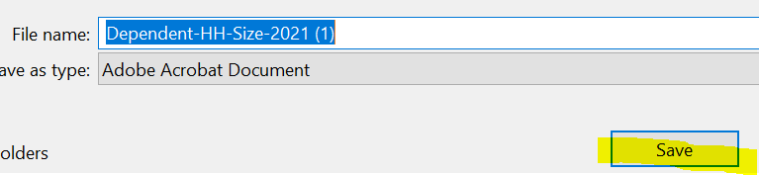

Step 3: Open File Explorer and find document

Step 4: Right Click File and Select Open with Adobe Acrobat Reader DC

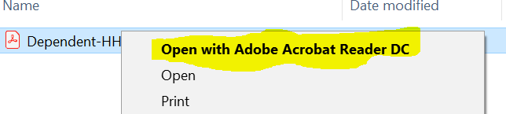

Step 5: You should now see a fillable signature section

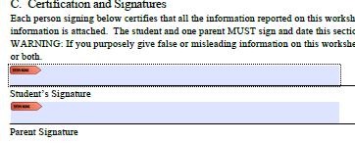

Step 6: After completing the form Click on Student Signature

You should get the following and select create a new digital ID and click continue

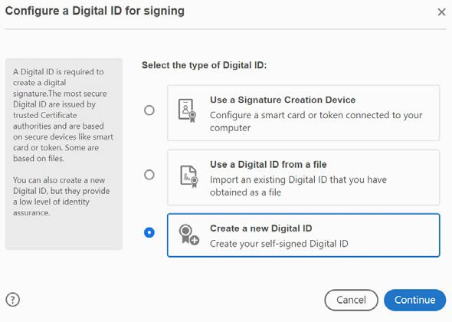

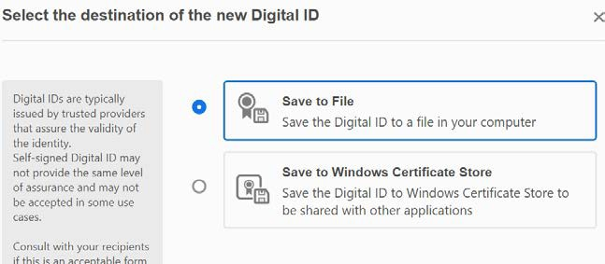

Step 8: Enter name and email and select continue

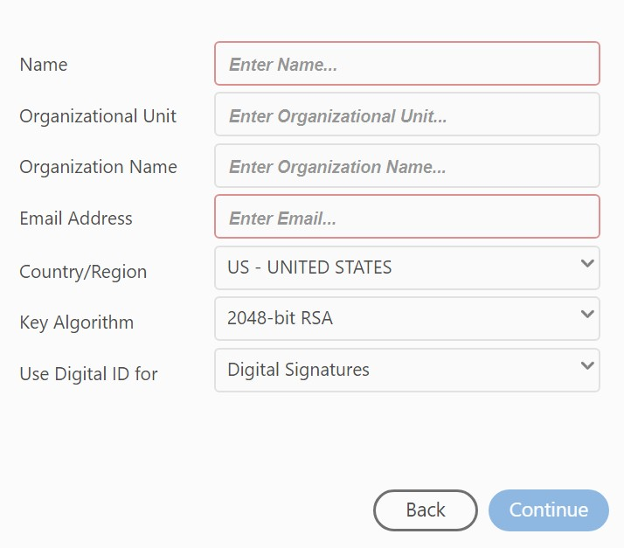

Step 9: Create a password and select Save

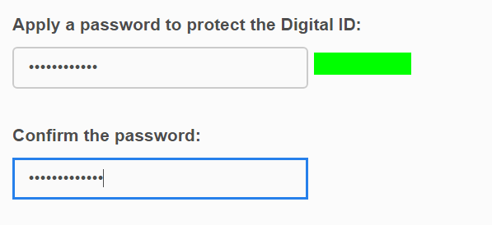

Step 10: You should now see your signature, enter the password previously created in step 9 and select Sign

Step 12: Confirm Save As; Select Yes

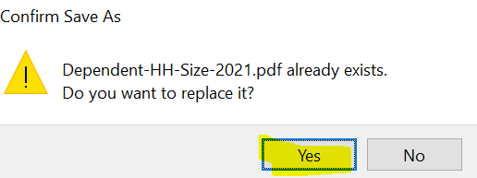

Step 13: Your document is now signed

Documents may be submitted through email at financialaid@tncc.edu or our website https://mysupport.tncc.edu/sims/helpcenter/common/layout/SelfHelpHome.seam?inst_name=vccs-thomasnelson

Third/Final Method: Hand sign electronically

Some forms do not have the option to sign as shown above, in this method you will learn how to sign a document by creating digital hand signature.

Step 1: Follow steps 1-4 from the Second Method

Step 2: If signature field does not give the option to sign it may look like this

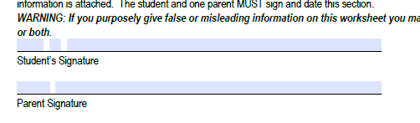

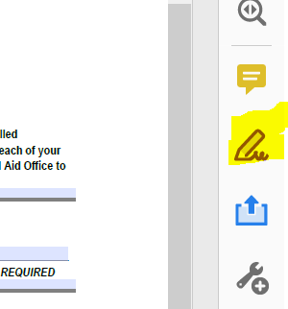
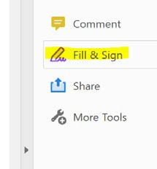
Step 3: On the right side of the page you may see one of the following options

Select the fill and sign option

OR

Step 5: Select Add Signature

Step 6: Select Draw

Step 7: Use your Cursor to sign your name and select Apply

Step 8: Position signature on signature line

Step 9: Save document and submit

Documents may be submitted through email at financialaid@tncc.edu or on our website https://mysupport.tncc.edu/sims/helpcenter/common/layout/SelfHelpHome.seam?inst_name=vccs-thomasnelson

