****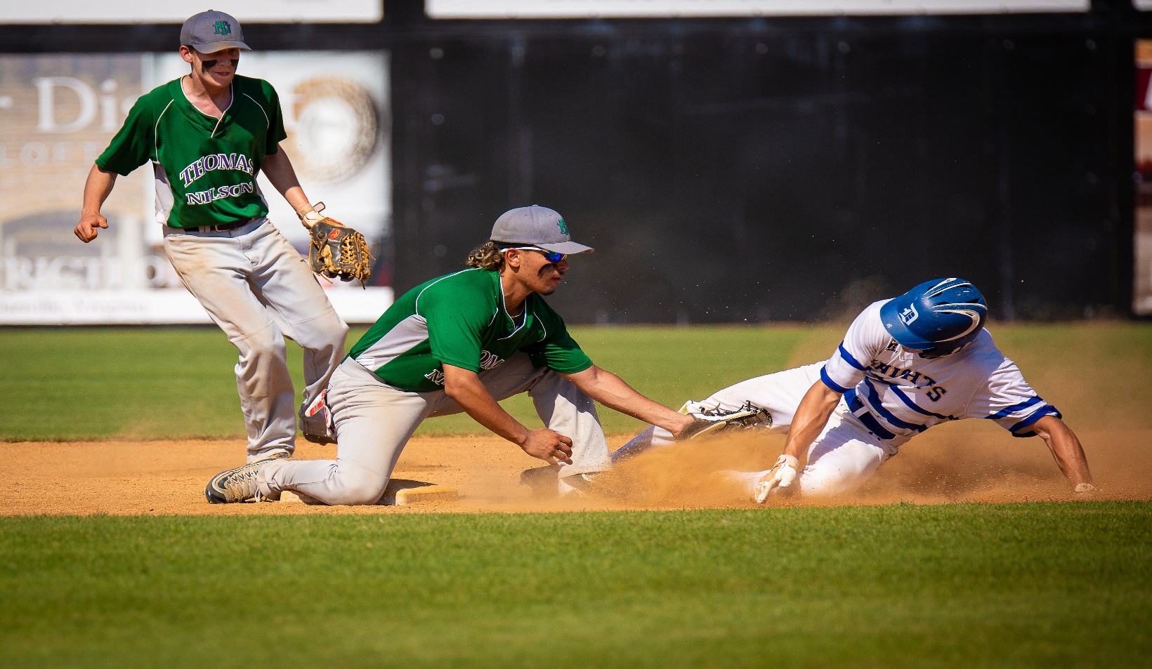

**Join us for the Hampton Roads Cup sponsored by the NN Apprentice School**

Wed, Feb 6th – 2:30 PM at War Memorial Stadium vs Bryant & Stratton

Thur., Feb 7th – 12:00 PM at War Memorial Stadium vs Paul D. Camp

Thur., Feb 7th – 2:30 PM at War Memorial Stadium vs Stratford

Sat., Feb 9th – 12:00 PM at War Memorial Stadium vs Apprentice

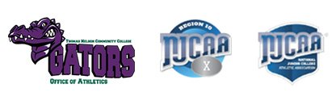In Baseball as in Life, Everything Important is at Home

**Join the Gator Baseball team – Contact Coach Ben Delgado**

**(757) 232-9693**

**Or call the Athletic & Intramural Office**

**@ (757) 825-3888**

**2019 Schedule online**

**Athletics@tncc.edu**